WELCOME TO SCOUTING!!!
As your child begins an exciting and enriching year in the Scouting program, it is very dependent on the volunteer leadership and support of the entire Scouting organization. Good parental assistance and financial support helps provide a strong organization. A strong organization helps provide a strong Scouting program, from which your child and the other scouts will greatly benefit!
This fall you will be asked to pay annual membership dues by your pack or troop. $24 dollars of these dues will help support Scouting at the National level, including the overall Scouting program, materials, and resources. Your pack or troop may also elect to provide money towards “Boy’s Life” magazine, a monthly publications with lots of Scouting ideas and stories. The balance of your annual dues pays for all the pack or troop equipment, scout awards, and general unit operations. NONE of your dues go to supporting our local Scout council, the Mount Diablo Silverado Council (MDSC). The local council is vital to providing help, resources, programs, camps, and many other items to the local units (packs, troops, etc.) to have a great program.
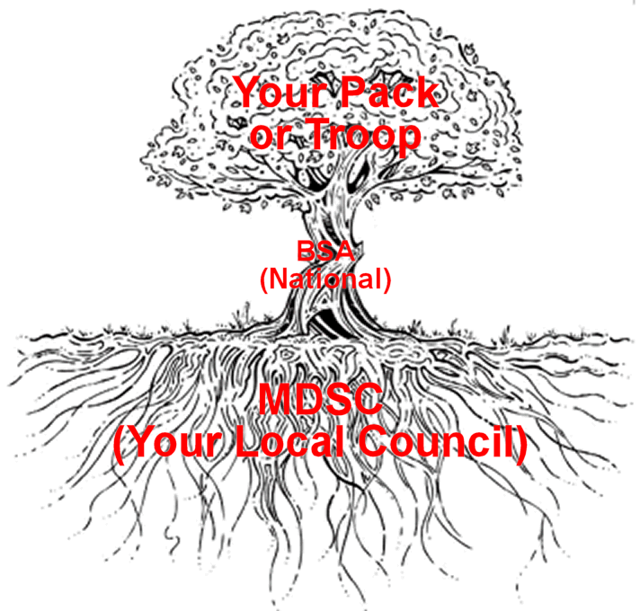
Much like a tree, your pack or troop benefits from having a strong support system (the roots and trunk) from the council and national offices, providing the needed help and resources (nutrients) for the pack or troop (tree) to grow and thrive. Our local council, much like the roots of a tree, is often out of sight but provide a vital service to the success of the pack or troop. A significant amount of financial support for our council comes from our Friends of Scouting (FOS) program. In February families will be asked to donate (as they are able) to our Friends of Scouting (FOS) program to support our local council. Your support is greatly appreciated!
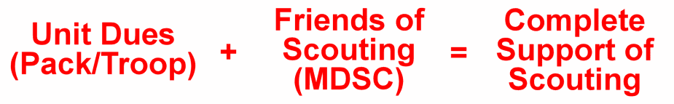
In summary, please support Scouting at all levels!
- Local unit (pack/troop) dues in the fall
- Friends of Scouting donation (for our local council) in February
- VOLUNTEER! Help your Scout leaders to provide an OUTSTANDING Scout program

